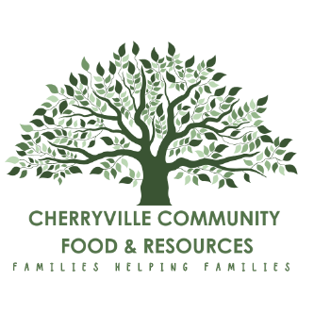
CHERRYVILLE SUMMER DAY CAMP
Recreation Program Leader
Cherryville Community Food and Resource Society is excited to offer a range of exciting activities and excursions for local youth throughout the summer months. We will be providing 4 week-long unique summer camp sessions for ages 5-12 and some one-day workshops for ages 12-17. Creating opportunity for fun learning and connection, we hope our youth will make long-lasting memories this upcoming year.
Position Summary
The Recreation Program Leader is tasked with the planning, coordination, execution, and oversight of recreational activities for youth during the summer months, which includes a four-week summer camp for children aged 5 to 12 running Monday to Friday throughout July and August 2026. Additionally, the Recreation Program leader will collaborate with CCFRS staff to develop one-day workshops and events targeting youth ages 12-17. Orientation and essential job training such as First Aid and WHMIS certification will be included. Overall, the Recreation Program Leader is responsible for ensuring the safety and well-being of all youth participants while fostering an enjoyable and enriching atmosphere.

Education, Training, and Experience:
- Experience and/or training working with youth ages 5 through 17
- Cleared criminal record check for working with Vulnerable Populations
- Valid First Aid & CPR certificate *available through CCFRS if needed
- Must be between the ages 18-30 years old
- Must be able to lift and support up to 50 pounds

Duties and Responsibilities for this Position Include:
- Plan and implement 4 unique week-long camps for Cherryville youth ages 5-12 (with support from CCFRS staff) throughout July and August
- Plan and implement One day Recreation events for youth – Ages 12-17
- Work collaboratively with the Recreation Program Assistant and support day-to-day activities
- Monitor and observe youth behaviour to ensure safe environment is maintained
- Provide skill-building and social skills to youth where able
- Adhere to all program policies and procedures
- Understand emergency and safety protocols
- Ensure attendance checklists are completed daily and submitted to CCFRS staff on a weekly basis
- Help in the CCFRS office as needed

Hours:
This is a temporary summer position, consisting of 30 hours per week for 12 weeks starting June1st, 2026. Hourly rate will be $19.00/hour (including MERCS).

Please send resume to: cherryvilleyouth@ccfrs.ca or drop off your resume in person at CCFRS, Monday to Thursday – 8am to 3pm. Open until position is filled with interviews scheduled throughout posting. June 1st , 2026 is official start date.
Cherryville Community Food and Resources Society
Physical location: 158 North Fork Road, Cherryville, BC V0E 2G3 Email: Cherryvilleyouth@ccfrs.ca Phone: 250-550-8902

